Name: Haseeb ul hassan roll no: 2022_mc_58

Experiement 01:Use of safety valve pneumatic

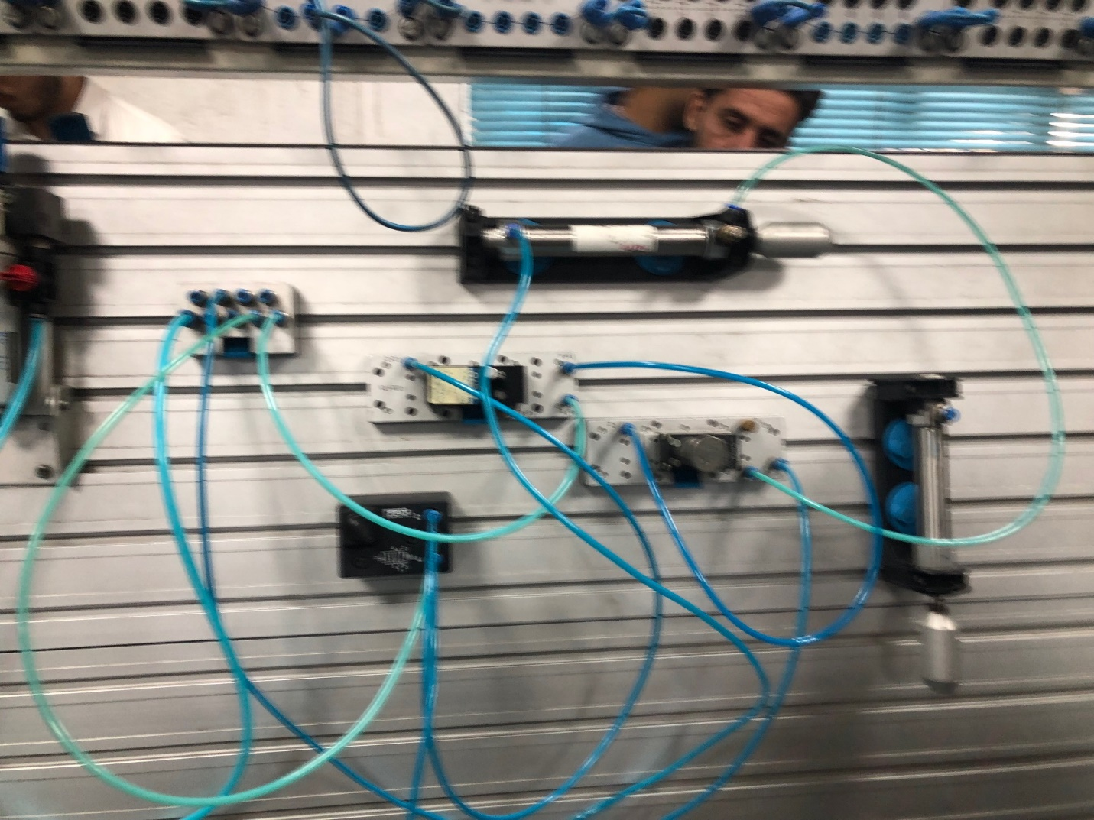

Experiement 2:basic Hydraulic actuator using eletctric switch

